**CSN-352: Compiler Design Mini Project**



Team Id - 3

Project no. - 44

Member 1

Name – Anand Chourasia

Enrollment no. - 20114008

Member 2

Name – Neerav Chittora

Enrollment no. – 20114062

Member 3

Name – Ujjawal Kumar Dubey

Enrollment no. – 20115160

The Algorithm:

* Taking Program as input Argument.
* Tokenizing the input Program (converting into separate tokens based on delimiters of the programming language i.e., python)
* Lexical Analysis (whether a token is valid according to the rules of python or not)
* Assigning the token symbols to the tokens (e.g., Variable, Constant, operator, etc.)
* Generating the Abstract Syntax Tree(AST) according to the Grammar of the python language.
* Traversing the AST maintaining the symbol table(Variables), visited and isErroneous variables, while checking for any syntax errors.

Intricacies:

1. Type Mismatch
   * For every operator node, check the datatype of its left and right nodes, if they are different then there is a type Mismatch.

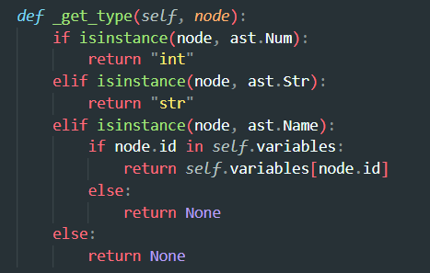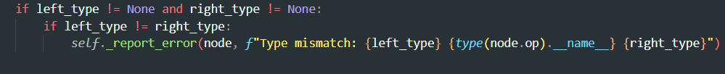

1. Uninitialized Variable
   * Every time a variable is used, we will check if an instance of it exists in the Variables map (i.e., Symbol Table).
   * If it does not exist, then the checker throws an error in the visit_Name() function.

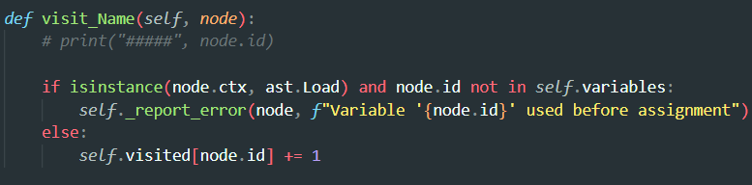

1. Division By Zero
   * Division by zero is handled in the visit_BinOp() function, where it checks whether the right node of the ‘/’ operator has the value ‘0’.
   * If it is so, then it throws an error.

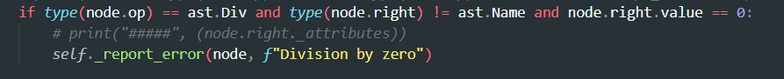

1. Unused Variable
   * For this purpose, we have kept a visited mapping where, if we visit any variable then the corresponding counter is increased.
   * In the end if the counter of any particular variable the visited map is less then equal to 1 (initialized at the time of assignment), then that variable is marked as unused.

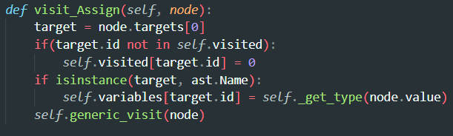

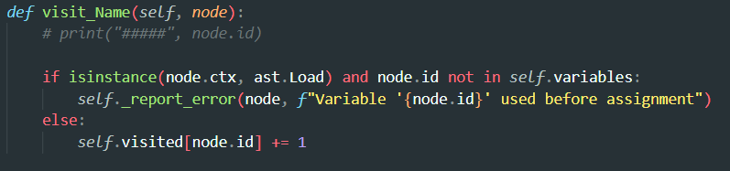

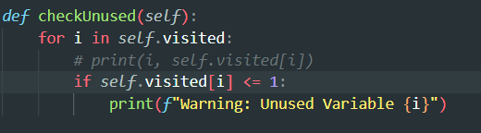

Test Cases:

1. No Error

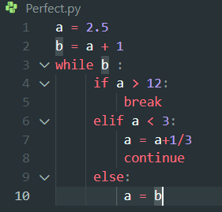



1. Syntax Error

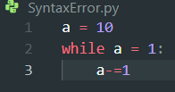

1. Type Mismatch

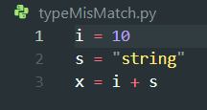

1. Uninitialized Variable

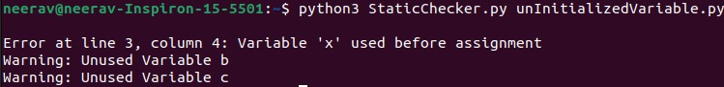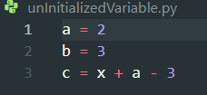

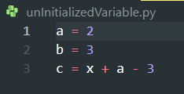

1. Unused Variable

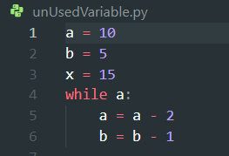

1. Division by Zero

